MSFS Mod Manager GUI
Quick Start Guide

- for version 0.1.0 -
- last updated 2022-04-11 -

First Start
Upon first starting the application, it will automatically detect the folder where mods/packages for Microsoft Flight Simulator are installed and ask you for confirmation. You can change the detected path here as you require, in case the detection went wrong.
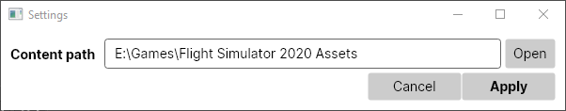
Main Window Overview
The main window displays information of all currently installed packages, allows the user to update or remove them as well as adding sources for new packages.
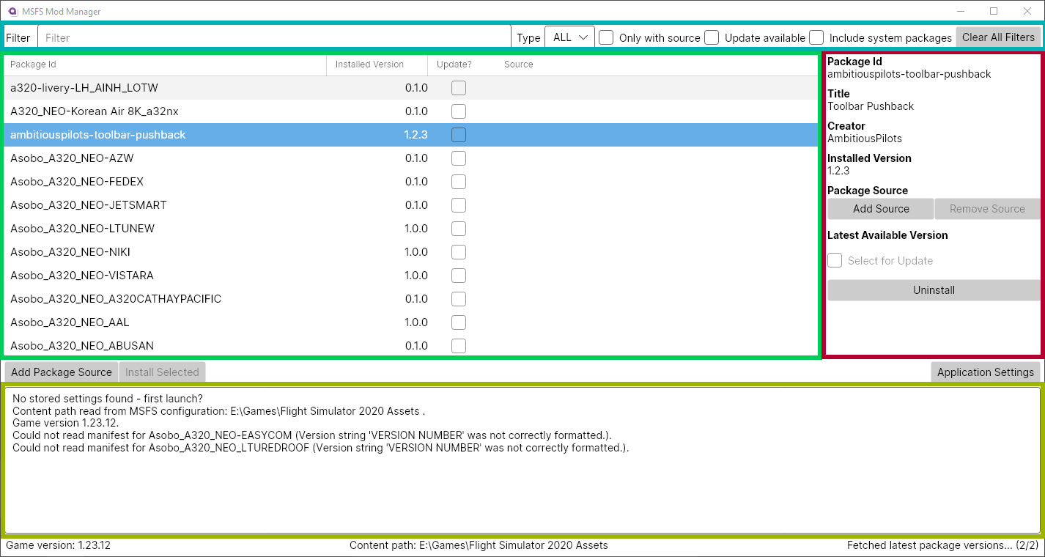
It is visually separated into the following main regions:
Package List: Displays a list of all currently known packages, their installed version number and information about the source from which they were installed (if available).
Filtering options for package list: This allows you to filter the package list to display only packages of a certain type, that match a certain name, or only those that have updates available (or any combination of these and more options).
Detailed information for selected package: If a package is selected (by clicking on it) from the package list, more details about it are shown in this view. From here it is also possible to add, edit or remove an installation source for the package, mark it for updating or uninstall it. This will also show whether there are newer versions available than the one currently installed, if a package source is added for the package.
Log view: Displays a text log of everything going on in the background. If the application encounters an error, for example because it cannot download and install a package, details about it will appear here. The log will also show warnings, e.g., if some packages do not provide information (as is the case in the screen above with version numbers for two installed packages).

Note About Packages
Microsoft Flight Simulator organises additions/modifications to the base game in so-called packages. Each package is a self-contained piece of software that adds features to the game or modifies existing behaviour. A package is uniquely identified by a package name/id, which is reflected in the folder name of the packages contents in the MSFS content folder. Packages may depend on the presence of (specific versions) of other packages in order to work correctly. Each package contains a file called “manifest.json” which, among other meta-information about the package, lists such dependencies.

Adding a New Package
In order to install a new package or update an existing one, you will need to add an installation source for it. This tells MSFS Mod Manager where to look for new versions of the package. In order to add a package source for a new package, click the “Add Package Source” button of the main window (highlighted below).
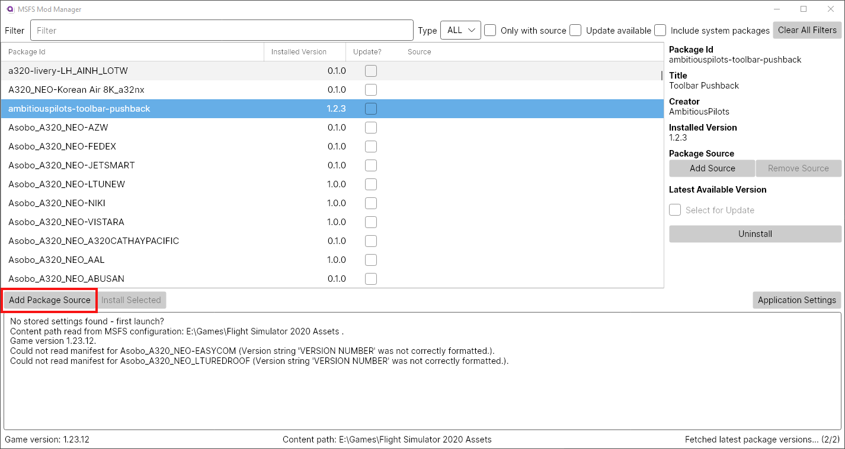
This will open the “Add Package” dialog. Enter the web address (URL) where the package is hosted in the “Source URL” text field (the lower of the two). MSFS Mod Manager currently only supports sourcing packages from GitHub.
Sourcing Packages from GitHub
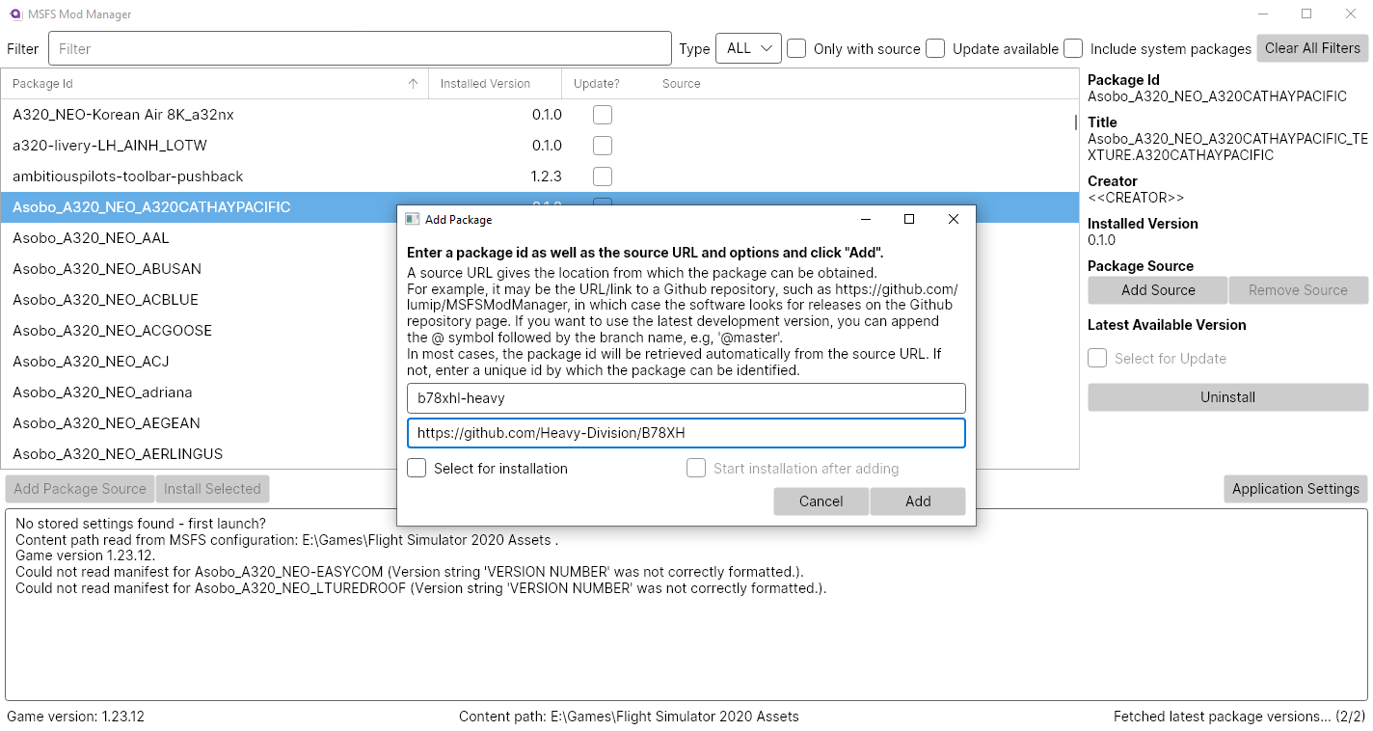
To source a package from GitHub, simply enter the URL of the GitHub Repository webpage, i.e., https://github.com/<Organisation>/<Repository>. This is demonstrated below for the B78XH mod by Heavy Division (https://github.com/Heavy-Division/B78XH) as an example.
MSFS Mod Manager will then attempt to discover the package id automatically by scanning the repository for the “package.json” file from which contains the package id. If no such file is found, you have to enter a package id yourself in the upper of the two text input fields of the “Add Package” dialog window.
Clicking “Add” will then add a new entry with the detected (or entered) package id and the chosen source URL to the package list in the main window and close the “Add Package” dialog.
GitHub Release Asset Filtering
By default MSFS Mod Manager will scan through the list of releases on GitHub to determine installation candidates for the package. This requires that the GitHub release consists of a single zip file containing all the package data to install. If a release contains several zip files, e.g. for different variations of the package, you have to provide a filter to select the correct one in form of a regular expression after the source URL: https://github.com/<Organisation>/<Repository> <Filter Regex>.
Sourcing from GitHub Branch
You can alternatively configure the program to instead follow the latest development version on a specific branch of the GitHub repository. To do so, enter as the source URL https://github.com/<Organisation>/<Repository>@<Branch> in the “Add Package” dialog.

Installing or Updating Packages
In order to install or update a package, select it for installation/updating by checking the checkbox in “Update?” column of the package list in the main window or the corresponding checkbox from the package detail panel on the right hand side of the main window. Note that this is only possible for packages for which a package source was added.
Once you have selected all packages you want to install or update, click the “Install Selected” button below the package list in the main window, which will bring up the installation dialog window.

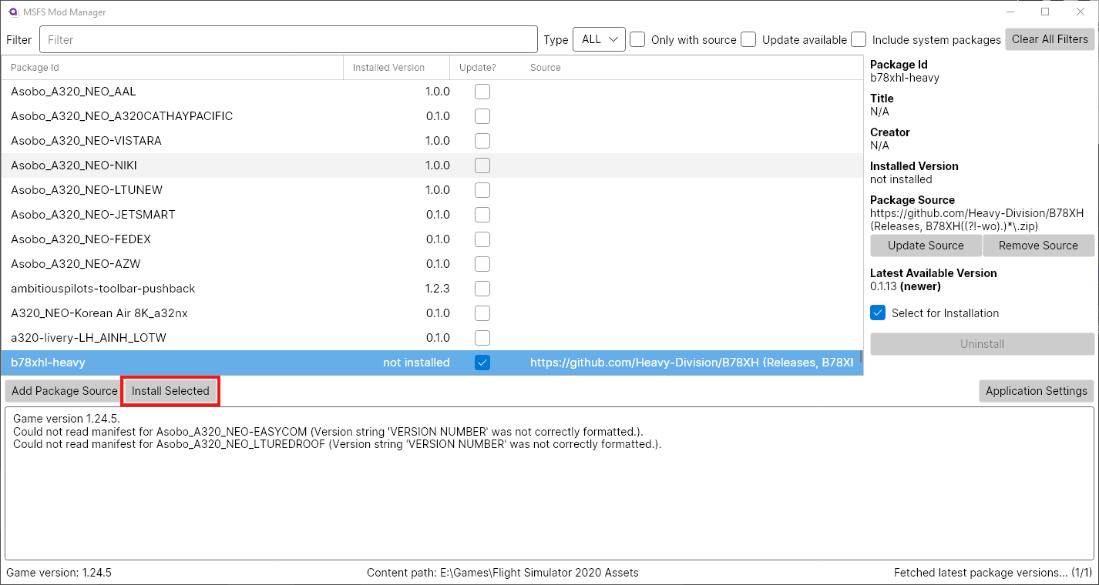
The installation dialog window first scans the packages selected for installation/updating to ensure that all dependencies (i.e., packages which the packages selected for installation/updating require to function) are available. To be deemed available, the dependencies must either be already installed, or have a package source added from which a suitable version can be source by the program. If the latter is the case, a suitable version will also be added to the list of packages to be installed. If neither is the case, the installation cannot proceed until you either install the missing dependency manually or add a package source for it.
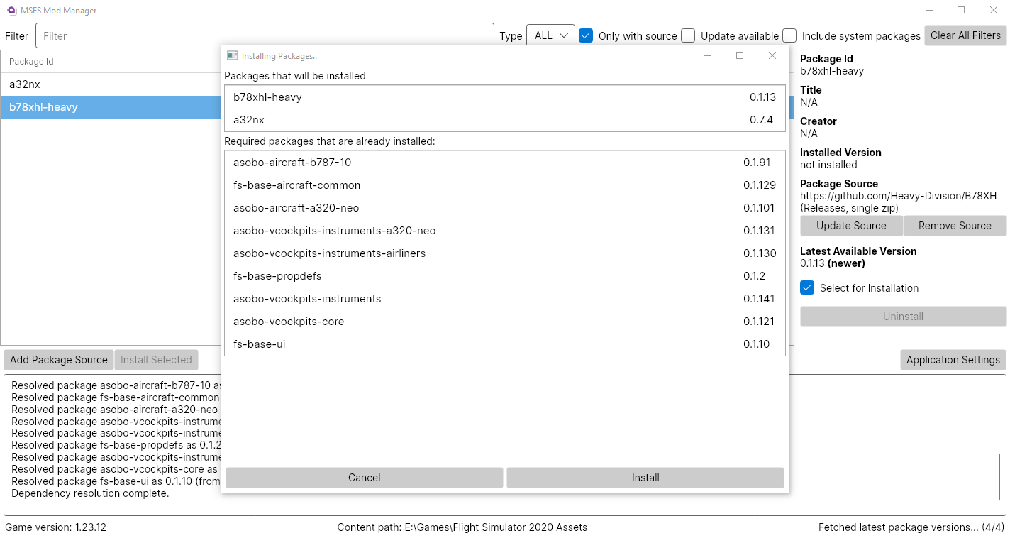
The installation dialog window displays a summary of this process’ result, highlighting which packages will be installed (and in which version), and which dependencies were already installed. You can check the results and click “Install” to proceed with the installation.
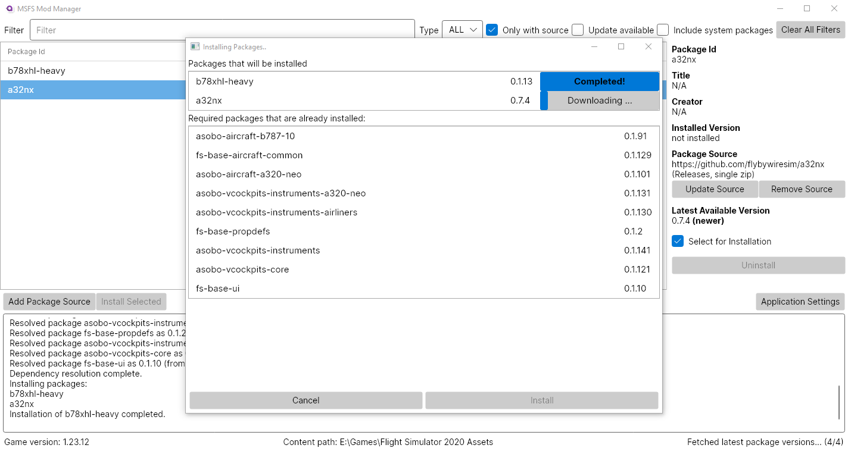
The installation dialog window then shows the progress of the installation.

Uninstalling Packages
To uninstall a package, select it from the package list in the main window to bring up its details in the package details panel on the right hand side. Then click “Uninstall”, which will open the uninstallation dialog window.
The uninstallation dialog window functions analogously to the installation dialog window described in the previous section. It will identify all installed packages that depend on the package that is selected for uninstallation and mark them for uninstallation as well. Upon confirmation by the user, all these package will be removed.

Getting Help and Reporting Bugs
Please note that MSFS Mod Manager is under active development and not thoroughly tested. As such, you may run into the odd problem or unexpected behaviour. If this is the case, please check first whether there is a new release that may already fix your problem from our GitHub repository page: https://github.com/lumip/MSFSModManager/releases.
If this is not the case or you need general help, please do not hesitate to file an issue using the issue tracker on GitHub: https://github.com/lumip/MSFSModManager/issues.
Please provide a succinct description of the problem you encounter, including steps to reproduce it and the program version you are using.

Package authors usually need to created a “package.json” file that contains the package id. However, this file is usually only relevant for the development of packages and typically not contained in the installation packages for end users. MSFS Mod Manager therefore derives the package id from the folder name.
If you do not know what the correct package id to enter is, you can choose any name for the package that is unique on your system.
An example for this is the B78XH package from Heavy-Division up to version 0.1.10. The filter regex for MSFS Mod Manager to work with these older versions is B78XH((?!-wo).)*\.zip.

